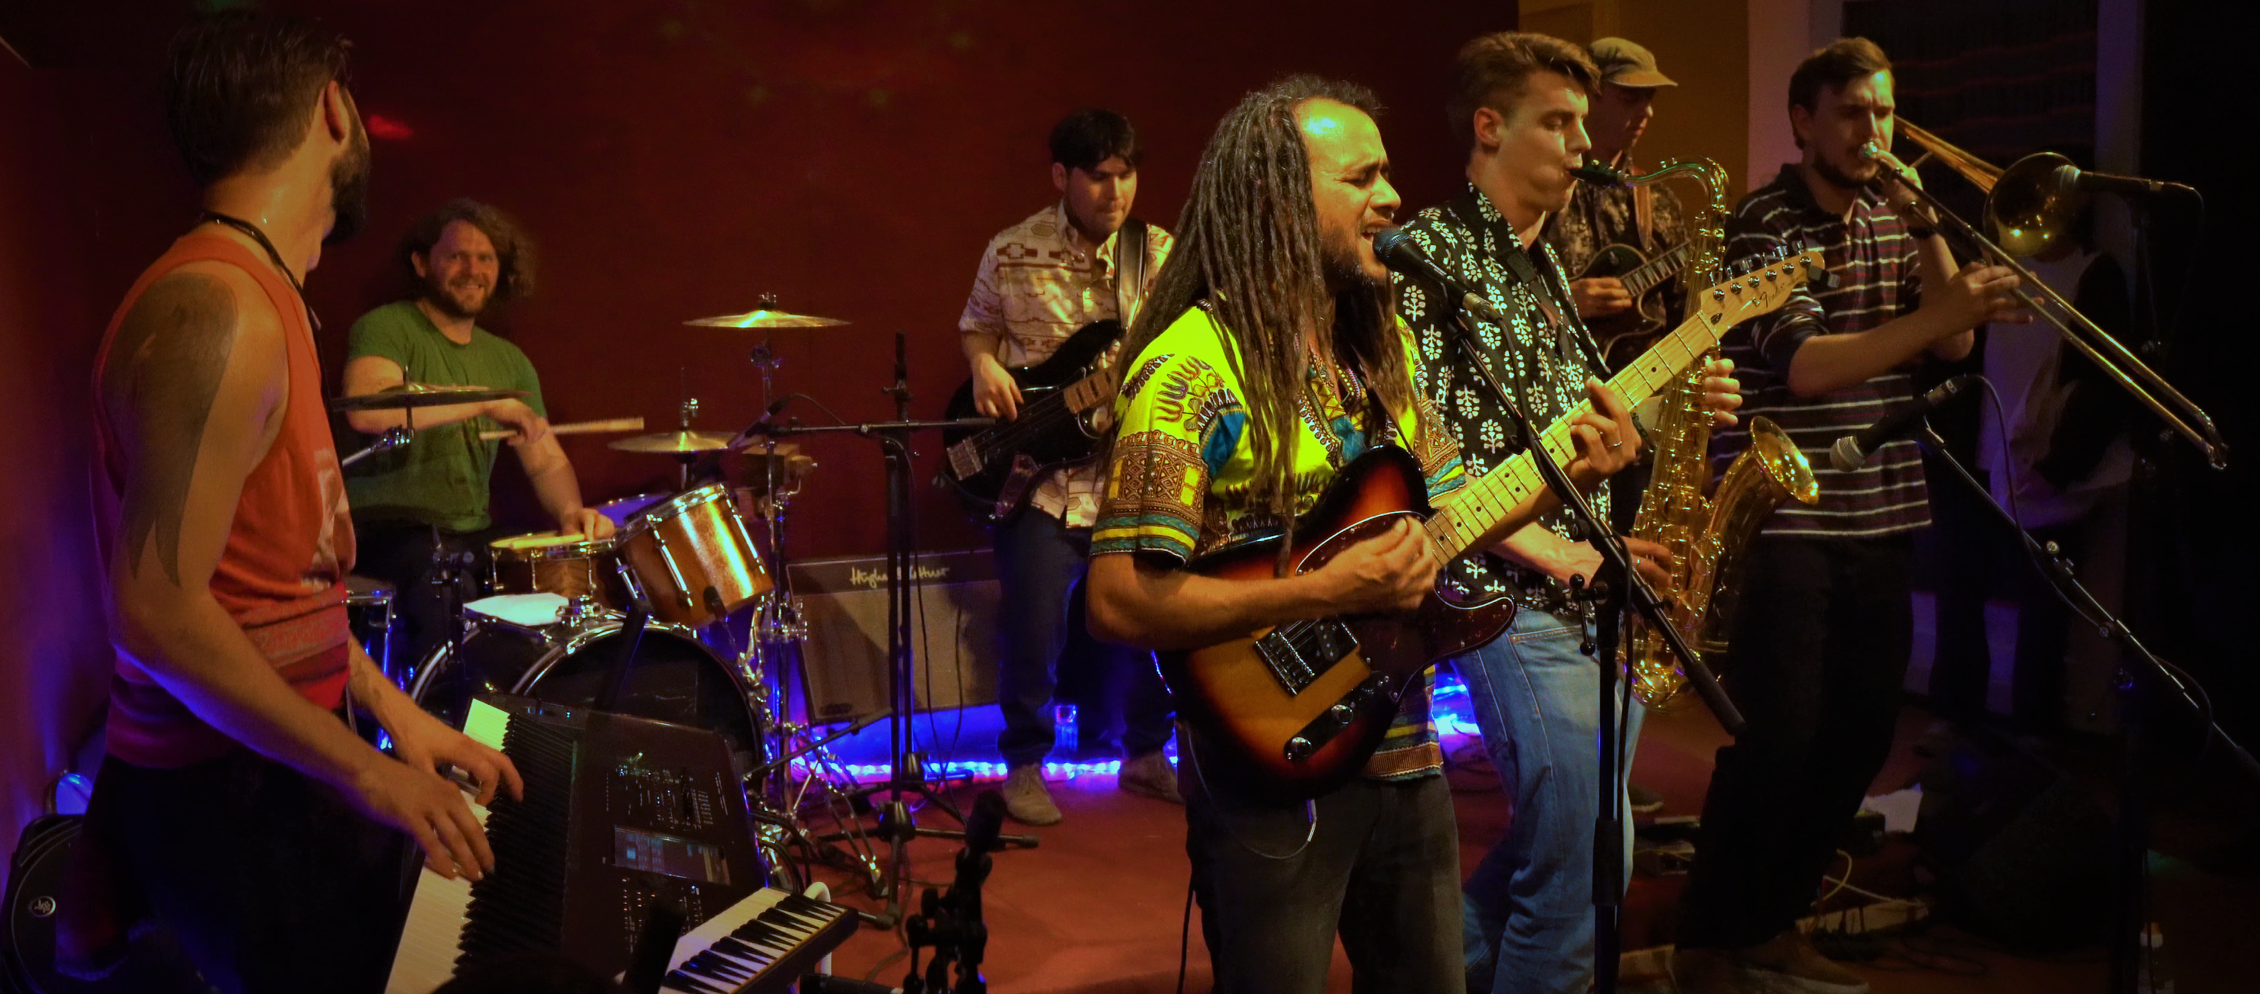
BIOGRAPHY
Crownforest is a eight piece reggae band based in Berlin, Germany. Coming from Mauritius, Cuba, Denmark, Chile, England, Brazil and Germany. They play original music and have been performing for the last three years. Their multicultural background shapes their sound into a mixture of Rootsreggae, Dub and afro-latin rhythms. The Message of the music confronts you with the reality and the injustice of today`s world. Crownforest brings a strong message of awakening through conscience lyrics, solid rhythms, infectious bass and soul lifting brass lines. The result is an exciting and groovy music that is hard not to meditate, dance and fly to.

Videos
https://www.youtube.com/watch?v=Hf5ECDdzCX4
https://www.youtube.com/watch?v=HeAjJTgTvw4
https://www.youtube.com/watch?v=pLskJpXCiCs
https://www.youtube.com/watch?v=bGJkBf4ICME

Audio
https://soundcloud.com/user-928363873

Web
www.crownforest.de

Booking
David Blackburn
crownforestband@gmail.com
004915739224219

